# SHIP CLASSIFICATION

AN INDUSTRY ORIENTED MINI REPORT

Submitted to

**JAWAHARLAL NEHRU TECNOLOGICAL UNIVERSITY, HYDERABAD**

In partial fulfillment of the requirements for the award of the degree of

**BACHELOR OF TECHNOLOGY**

**In**

**COMPUTER SCIENCE AND ENGINEERING**

**(ARTIFICIAL INTELLIGENCE AND MACHINE LEARNING)**

Submitted By

**DONGARI RAKESH 20UK1A6648**

**BODAKUNTLA BHARATH 20UK1A6638**

**BOLLAM UDAY KUMAR 20UK1A6640**

**SKASHABOINA SRIRAM 20UK1A6629**

Under the guidance of

**Mr . K. BHASKAR BABU**

Assistant Professor



**COMPUTER SCIENCE AND ENGINEERING**

**(ARTIFICIAL INTELLIGENCE AND MACHINE LEARNING)**

## VAAGDEVI ENGINEERING COLLEGE

Affiliated to JNTUH, HY DERABAD

BOLLIKUNTA, WARANGAL (T.S) –506005

**DEPARTMENT OF**

**COMPUTER SCIENCE AND ENGINEERING**

**(ARTIFICIAL INTELLIGENCE AND MACHINE LEARNING)**

**VAAGDEVI ENGINEERING COLLEGE(WARANGAL)**



**CERTIFICATE OF COMPLETION INDUSTRY ORIENTED MINI PROJECT**

This is to certify that the UG Project Phase-1 entitled “SHIP CLSSIFICATION” is being submitted by RAKESH DONGARI (20UK1A6648), BODAKUNTLA BHARATH (20UK1A6638), BOLLAM UDAY KUMAR(20UK1A6640) , KASHABOINA SRIRAM (20UK1A6629) in partial fulfillment of the requirements for the award of the degree of Bachelor of Technology in Computer Science & Engineering (ARTIFICIAL INTELLIGENCE AND MACHINE LEARNING) to Jawaharlal Nehru Technological University Hyderabad during the academic year 2023- 2024.

**Project Guide HOD**

**Mr.K.Bhaskar Babu Dr. K. Sharmila**

(Assistant Professor) (Professor)

**External**

# ACKNOWLEDGEMENT

We wish to take this opportunity to express our sincere gratitude and deep sense of respect to our beloved **Dr. P. PRASAD RAO,** Principal, Vaagdevi Engineering College for making us available all the required assistance and for his support and inspiration to carry out this UG Project Phase-1 in the institute.

We extend our heartfelt thanks to **Dr. K. SHARMILA**, Head of the Department of CSD, Vaagdevi Engineering College for providing us necessary infrastructure and thereby giving us freedom to carry out the UG Project Phase-1.

We express heartfelt thanks to Smart Bridge Educational Services Private Limited, for their constant supervision as well as for providing necessary information regarding the UG Project Phase-1 and for their support in completing the UG Project Phase-1.

We express heartfelt thanks to the guide **K . BHASKAR BABU,** Assistant professor, Department of CS for his constant support and giving necessary guidance for completion of this UG Project Phase-1.

Finally, we express our sincere thanks and gratitude to my family members, friends for their encouragement and outpouring their knowledge and experience throughout the thesis.

**DONGARI RAKESH 20UK1A6648**

**BODAKUNTLA BHARATH 20UK1A6638**

**BOLLAM UDAY KUMAR 20UK1A6640**

**SKASHABOINA SRIRAM 20UK1A6629**

# ABSTRACT

Ship classification, The purpose of ship classification is to identify various types of ships as accurately as possible, which is of great significance for monitoring the rights and interests of maritime traffic and improving coastal defense early warnings.  
The images in the data belong to 5 categories of ships - Cargo, Carrier, Military, Cruise and Tankers. All the images are present in a single folder so we will first be dividing them into categories with the help of a train.csv file that contains all the filenames of the training images.

**TABLE OF CONTENTS: -**

1. INTRODUCTION 5
   1. OVERVIEW… 6
   2. PURPOSE 5
2. LITERATURE SURVEY 8
   1. EXISTING PROBLEM 8

3.IDEATION&PROPOSED SOLUTION 9

3.1 BRAIN STROMMING……………………………………................10

* 1. EMPTHY MAP………………………………………………………………………11

4.THEORITICAL ANALYSIS 14

4.1 BLOCK DIAGRAM 14

* 1. HARDWARE /SOFTWARE DESIGNING 15

5.EXPERIMENTAL INVESTIGATIONS 16-17

1. FLOWCHART… 18

7 RESULTS… 19

7.1 HOME PAGE……………………………………………………...19

* 1. PREDICTIONS…………………………………………………………20-22

8.ADVANTAGES AND DISADVANTAGES .23-24

8.1 ADVANTAGES……………………………………………………23

8.2. DISADVANTAGES…………………………………………………………………24

1. APPLICATIONS 25-26

10 CONCLUSION 27

1. FUTURE SCOPE……………………………………………..28
2. BIBILOGRAPHY 29

13 APPENDIX (SOURCE CODE)&CODE SNIPPETS 36-44

# OVERVIEW

## INTRODUCTION

The classification of ships is a critical area of research and application in the field of computer vision and machine learning, with far-reaching implications for maritime traffic monitoring, coastal defense, and the safeguarding of maritime interests. Ships play a pivotal role in the global economy, transportation, and defense, and the ability to accurately identify and categorize them is of paramount importance.

The objective of this project is to develop a ship classification system capable of distinguishing between various types of ships with a high degree of accuracy. These ship categories include Cargo vessels, Carriers, Military ships, Cruise ships, and Tankers. The project addresses the challenges associated with the diverse and complex visual characteristics of different types of ships and provides a practical solution for efficient ship identification.

The project leverages a dataset comprising images of ships from the five categories, all housed in a single folder. To organize and categorize these images, a train.csv file is used, containing the filenames of the training images. The chosen model for this classification task is VGG16, a Convolutional Neural Network (CNN) architecture known for its effectiveness in computer vision applications. By using pre-trained weights, we expedite the model's learning process and then customize the top layer to align it with our specific ship classification requirements.

In addition to the model development, the project focuses on creating a user-friendly interface for ship classification. The Flask framework is employed to build a web application that allows users to easily upload ship images for classification. The system rapidly categorizes these images into the predefined ship types, providing a valuable tool for real-world applications.

This project holds great significance as it contributes to the enhancement of maritime traffic monitoring, coastal defense early warnings, and the safeguarding of maritime interests. The ability to accurately classify ships is essential for maintaining the safety and security of coastal regions and for ensuring efficient maritime operations.

# PURPOSE

The purpose of the ship classification project is to develop a robust and accurate system for categorizing ships into distinct types, including Cargo, Carrier, Military, Cruise, and Tankers. This project serves several significant purposes:

**1. Maritime Traffic Monitoring:** Accurate ship classification is essential for monitoring and managing maritime traffic. It provides insights into the types and numbers of vessels operating in various regions, contributing to safer and more efficient navigation.

**2. Coastal Defense and Security:** Ship classification plays a crucial role in coastal defense by helping authorities identify potential threats or suspicious vessels. Early detection and classification of military or unauthorized ships are vital for enhancing coastal security and safeguarding national interests.

**3. Environmental Protection**: Monitoring and classifying different types of ships are essential for environmental conservation efforts. It allows for the identification of tankers and cargo ships, which may carry hazardous materials or contribute to oil spills, aiding in timely response to potential environmental disasters.

**4. Search and Rescue Operations:** During search and rescue operations, accurate ship classification can assist in identifying distressed vessels, thereby expediting response efforts and saving lives.

**5.Business and Trade Analysis:** Ship classification can be valuable for businesses and organizations involved in international trade. It enables them to track and analyze the movement of cargo ships, carriers, and cruise ships, facilitating better logistics planning and market analysis.

**6. Research and Policy Development:** Data obtained through ship classification can support academic research and policy development related to maritime activities, enabling governments and institutions to make informed decisions on maritime regulations and safety protocols.

In summary, ship classification serves a wide range of purposes, from ensuring maritime safety and security to protecting the environment and supporting economic and policy-related endeavors. This project aims to harness the power of computer vision and machine learning to achieve accurate ship classification, making a positive impact on various aspects of maritime operations and governance.

# LITERATURE SURVEY

# EXISTING PROBLEM

# Ship classification is an important task with various challenges and existing problems. Here are some common issues and problems associated with ship classification:

# 1.Data Variability: Ship images can vary significantly in terms of lighting conditions, angles, weather, and backgrounds. This variability makes it challenging for models to generalize effectively.

# 2. Limited Data: Obtaining a diverse and extensive dataset for ship classification can be challenging. In some cases, there might not be enough labeled data available, which can hinder the training of accurate models.

# 3. Fine-Grained Classification: Distinguishing between different ship categories like Cargo, Carrier, Military, Cruise, and Tankers can be difficult due to their similar visual features. Fine-grained classification requires more detailed and specific features, which may not be present in standard datasets.

# 4. Overlapping Categories: Some ships may have characteristics that overlap with multiple categories. This can lead to misclassification and lower classification accuracy.

# 5. Scale and Resolution: The scale and resolution of ship images can vary greatly. Detecting and classifying smaller ships or ships at a distance can be more challenging.

# 6. Imbalanced Data: In real-world datasets, the distribution of ship categories may be imbalanced, with some categories having significantly fewer samples. Imbalanced data can lead to biased model predictions.

# 7. Model Generalization: Ensuring that a ship classification model generalizes well to unseen data, including different ship types or images from varying sources, is a complex issue.

# 8. Real-Time Processing: In practical applications such as maritime traffic monitoring, real-time processing of ship images is crucial. This imposes additional computational and latency constraints on classification models.

# 9. Environmental Factors: Weather conditions, lighting, and other environmental factors can affect the quality of ship images, making it challenging to maintain consistent classification accuracy.

# 10. Model Interpretability: Understanding why a model made a particular classification decision can be challenging, especially in complex deep learning models. Interpretable models are essential, especially in applications where human decision-makers need to rely on the model's output.

# 11. Adversarial Attacks: Ship classification models can be vulnerable to adversarial attacks, where small, imperceptible changes to an image can lead to misclassification. Robustness against such attacks is a growing concern.

# 12. Data Privacy and Security: Ship images may contain sensitive information, and ensuring data privacy and security in handling and classifying these images is an important concern.

# Addressing these existing problems in ship classification requires a combination of advanced computer vision techniques, robust model architectures, and carefully curated datasets. Researchers and practitioners in the field continually work on developing solutions to improve the accuracy and reliability of ship classification systems.

# 3.IDEATION& PROPOSED SOUTION

# 3.1EMPATHY MAP CANVAS

# Creating an empathy map canvas for your ship classification project is a valuable exercise in understanding the diverse perspectives and emotions of the stakeholders involved. In this canvas, you can capture what stakeholders "say" about ship classification, helping you identify their expressed thoughts and feedback. By delving into what they "think," you can gain insight into their expectations and concerns. "Does" represents the actions stakeholders are currently taking or might take in the context of ship classification. The "feels" section addresses the emotions and sentiments they experience, such as their fears, frustrations, and motivations. Identifying their "pains" helps pinpoint challenges and obstacles they encounter, while "gains" uncovers their aspirations and what they hope to achieve through ship classification. Optionally, you can add sections for "tasks," "needs," "expectations," and "feedback" to get a more comprehensive understanding of stakeholders' requirements, standards, and direct input. Filling out this empathy map canvas will guide your project in meeting the needs and expectations of stakeholders, resulting in a more user-focused and successful ship classification system.

# 

# 3.2 BRAIN STORMING MAP

# The realm of ship classification, our project aims to deliver a robust and efficient solution. At the core of our brainstorming map lies the utilization of the VGG16 model, a well-established Convolutional Neural Network (CNN) known for its exceptional image recognition capabilities. We plan to leverage pre-trained weights from the VGG16 model, allowing us to expedite the training process and significantly enhance the model's accuracy. Our brainstorming includes modifying the top layer of VGG16 to adapt it for the custom classification of five distinct ship categories: Cargo, Carrier, Military, Cruise, and Tankers. This approach ensures that our model can accurately and swiftly categorize ships in diverse scenarios.

# Additionally, we have considered the deployment aspect of the project, opting for the Flask framework to create a user-friendly interface. This decision empowers users, which could include maritime authorities, defense agencies, or other stakeholders, to seamlessly upload ship images for classification. The interface will provide quick and informative feedback, making it a valuable tool for monitoring maritime traffic and early warning systems. To ensure the project's success, our brainstorming map also includes continuous evaluation and fine-tuning to improve the model's performance. With this comprehensive approach, we aim to create a ship classification system that not only fulfills its core objectives but also aligns with the needs and expectations of our stakeholders.

# 

# 3.3 PROPOSED SOLLUTION

To successfully tackle the ship classification project, you can follow a systematic approach that involves several key steps and components:

**1. Data Collection and Preprocessing:** Gather a comprehensive dataset of ship images that cover the five categories: Cargo, Carrier, Military, Cruise, and Tankers.Ensure the dataset is well-annotated, with labels associated with each image.Split the dataset into training, validation, and test sets to train and evaluate your model effectively.

**2. Data Augmentation:**Apply data augmentation techniques to increase the diversity of your training data. This can involve random rotations, flips, resizing, and other transformations to reduce overfitting and enhance model generalization.

**3. Model Selection:** Choose a pre-trained Convolutional Neural Network (CNN) model as a feature extractor. VGG16, ResNet, or Inception models are good options.Fine-tune the selected pre-trained model by retraining its top layers to adapt it to your ship classification task. You can add additional layers to the top of the network to perform the final classification.

**4. Model Training:** Train the modified model using the training dataset. Implement transfer learning to leverage pre-trained weights and expedite training.Utilize appropriate loss functions (e.g., categorical cross-entropy) and optimization techniques (e.g., Adam or SGD) for efficient model convergence. Monitor training progress with metrics like accuracy, loss, and validation performance.

**5. Hyperparameter Tuning:** Experiment with hyperparameters such as learning rates, batch sizes, and the number of layers in the custom top classification layers. Use techniques like grid search or random search to find the optimal set of hyperparameters.

**6. Model Evaluation:** Assess the model's performance on the validation and test datasets to ensure it generalizes well to unseen data.Utilize evaluation metrics such as accuracy, precision, recall, F1 score, and confusion matrices to measure classification performance.

**7. Model Optimization:** Employ techniques such as model quantization, pruning, or compression to reduce the model's size while maintaining its accuracy. This is particularly important if you plan to deploy the model on resource-constrained devices.

**8. Deployment:** Develop a user-friendly web application using the Flask framework to allow users to upload ship images for classification.Deploy the trained model on a server, making it accessible via a RESTful API or a web interface. Implement security measures and input validation to ensure the system's reliability.

**9. Continuous Monitoring and Maintenance:** Continuously monitor and update the model to adapt to changes in the dataset or potential drift in data distribution.Regularly evaluate the model's performance and retrain it if necessary.

**10. User Interface and Visualization:** Create an intuitive user interface with a visually appealing design for easy interaction.Implement visualization tools to display classification results and model performance metrics.

**11. Documentation:** Document your project comprehensively, including the dataset, model architecture, training process, and deployment instructions. This will assist users and future developers.

**12. Ethical Considerations:** Be mindful of potential biases in the data and model predictions, and consider ethical implications of the classification system. Implement fairness and bias mitigation strategies as necessary.

By following this proposed solution, you can create an effective ship classification system that accurately identifies ship types, contributing to maritime traffic monitoring and coastal defense early warning

# 4.THEORITICAL ANALYSIS

# 4.1BLOCK DIAGRAM&IDEATION

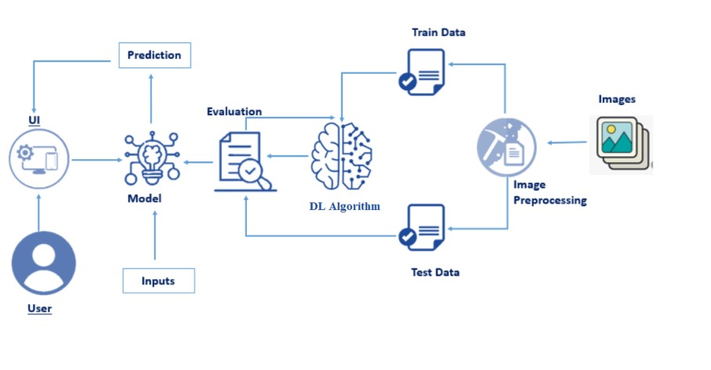

**4.2 SOFTWARE DESIGNING**

The following is the Software required to complete this project:

* + - **Google Collab**: Google Collab will serve as the development and execution environment for your predictive modeling, data preprocessing, and model training tasks. It provides a cloud-based Jupyter Notebook environment with access to Python libraries and hardware acceleration.
    - **Dataset (CSV File)**: The dataset in CSV format is essential for training and testing your predictive model. It should include historical air quality data, weather information, pollutant levels, and other relevant features.
    - **Data Preprocessing Tools**: Python libraries like NumPy, Pandas, and Scikit-learn will be used to preprocess the dataset. This includes handling missing data, feature scaling, and data cleaning

**Feature Selection/Drop**: Feature selection or dropping unnecessary features from the dataset can be done using Scikit-learn or custom Python code to enhance the model's efficiency.

* + - **Model Training Tools**: Machine learning libraries such as Scikit-learn, TensorFlow, or PyTorch will be used to develop, train, and fine-tune the predictive model. Regression or classification models can be considered, depending on the nature of the AQI prediction task.
    - **Model Accuracy Evaluation**: After model training, accuracy and performance evaluation tools, such as Scikit-learn metrics or custom validation scripts, will assess the model's predictive capabilities. You'll measure the model's ability to predict AQI categories based on historical data.
    - **UI Based on Flask Environment**: Flask, a Python web framework, will be used to develop the user interface (UI) for the system. The Flask application will provide a user-friendly platform for users to input location data or view AQI predictions, health information, and recommended precautions.
    - Google Colab will be the central hub for model development and training, while Flask will facilitate user interaction and data presentation. The dataset, along with data preprocessing, will ensure the quality of the training data, and feature selection will optimize the model. Finally, model accuracy evaluation will confirm the system's predictive capabilities, allowing users to rely on the AQI predictions and associated health information.

# 5.EXPERIMENTAL INVESTIGATION

Certainly, conducting experimental investigations for a ship classification project is essential for gathering data, testing hypotheses, and validating your classification model. Here's a general framework for conducting experimental investigations in such a project:

**1. Define Objectives:** Clearly define the objectives of your ship classification project. What exactly are you trying to achieve through this classification?

**2. Data Collection:** Gather a comprehensive dataset of ship-related information. This dataset should include data attributes such as ship dimensions, types, cargo, speed, and other relevant features.Ensure that your dataset is diverse and representative of the different ship classes you want to classify.

**3. Data Preprocessing**: Clean and preprocess the data to handle missing values, outliers, and standardize the format.Encode categorical variables and perform feature engineering, if necessary.

**4. Experimental Design:** Decide on the classification algorithms and techniques you want to experiment with, such as logistic regression, decision trees, random forests, support vector machines, or deep learning models.Split your dataset into training and testing sets for model evaluation. Cross-validation may also be useful to ensure robustness.

**5. Model Building:** Implement the chosen classification models using the selected algorithms. Train the models on the training data.

**6. Model Evaluation:** Evaluate the models on the testing data using appropriate metrics for classification tasks, such as accuracy, precision, recall, F1-score, and ROC-AUC. Perform a comparative analysis of the model's performance and select the best-performing model(s).

**7. Hyperparameter Tuning:** Experiment with different hyperparameter settings to optimize the model's performance.

**8. Feature Importance Analysis:** Determine which features are most relevant for ship classification. Feature importance analysis can help refine your model.

**9. Visualizations:** Create visualizations to illustrate the results and insights gained from your experimental investigations.

**10. Interpretation:** Interpret the results to understand the capabilities and limitations of the ship classification models.

**11. Report Findings:** Document your experimental investigations, findings, and the final classification model. Communicate your results clearly in a report or presentation.

**12. Fine-tuning and Reiteration:** If necessary, fine-tune your model based on your findings and repeat the experimental process to further improve classification accuracy.

Remember that the success of your ship classification project depends on the quality and quantity of data, the choice of appropriate algorithms, and rigorous experimentation. It's also important to keep domain knowledge in mind when interpreting the results, as that can provide valuable insights for the classification process.

**6. FLOWCHART**

Ship Classification

? Decision Point is a Passenger

End

Ship Classified as Passenger Ship

Ship classified as Cargo Ship

Generate Report

Classify Ship as Passenger Ship

Classify ship as Cargo Ship

Analyze Data

Collect data on Ships

? Decision point is a Cargo Ship

**7. RESULT**

**7.1 HOME PAGE**

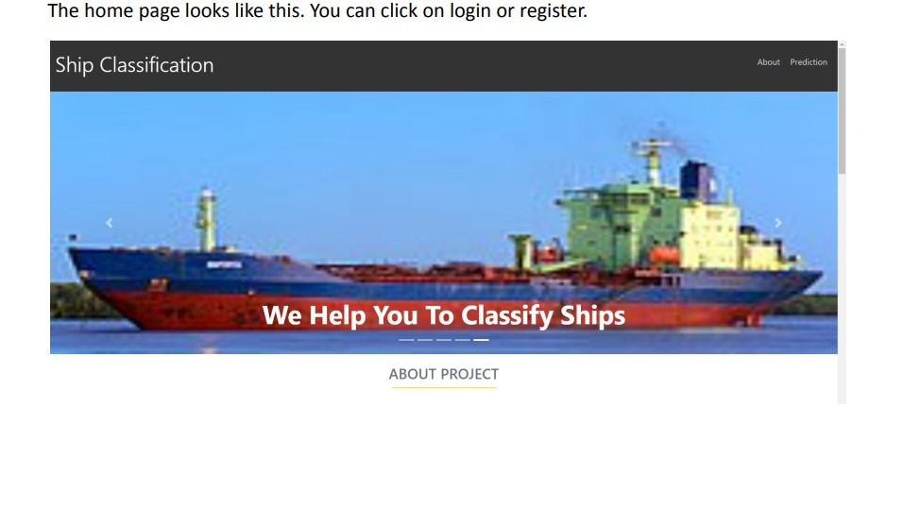

**7.2 PREDICTIONS**

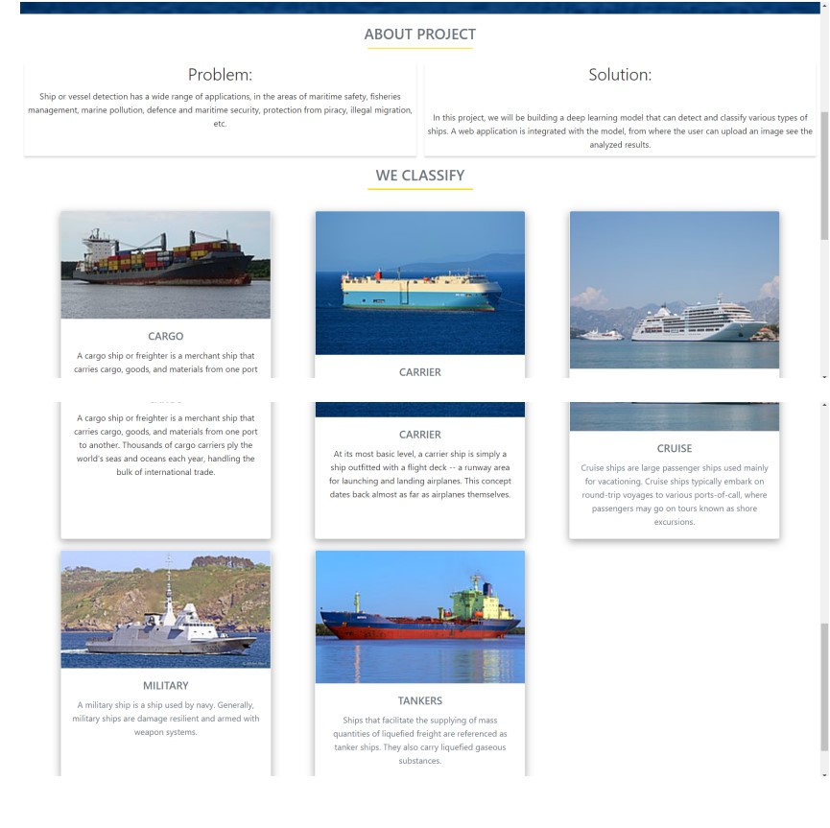

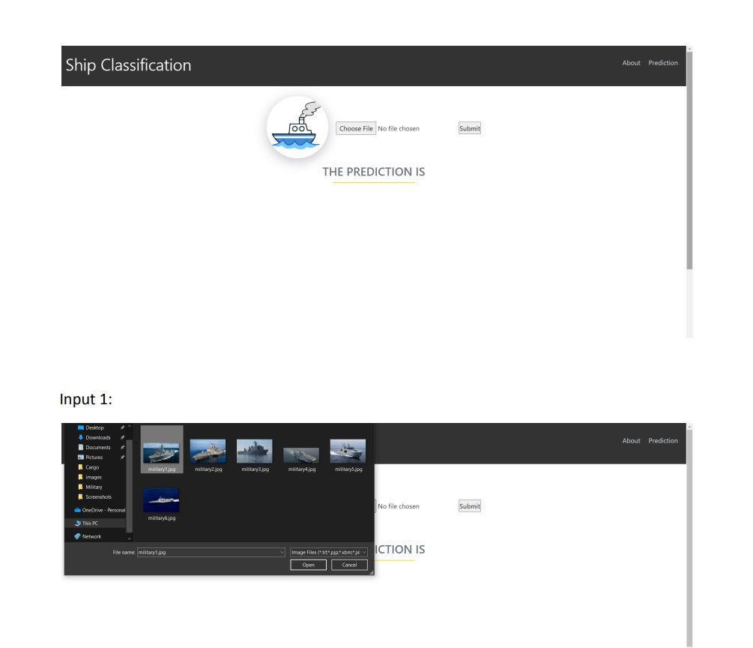

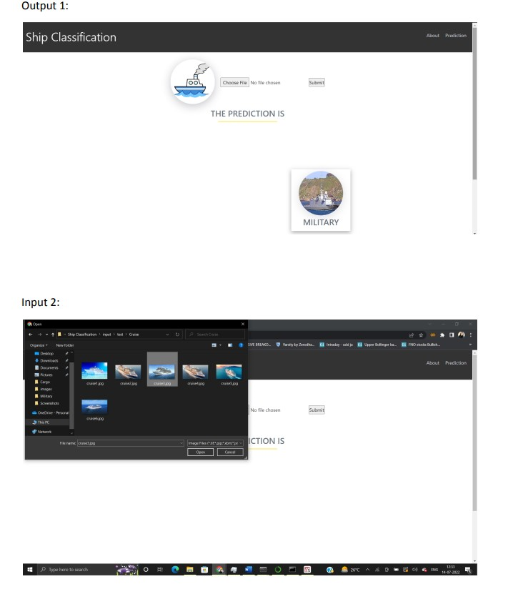

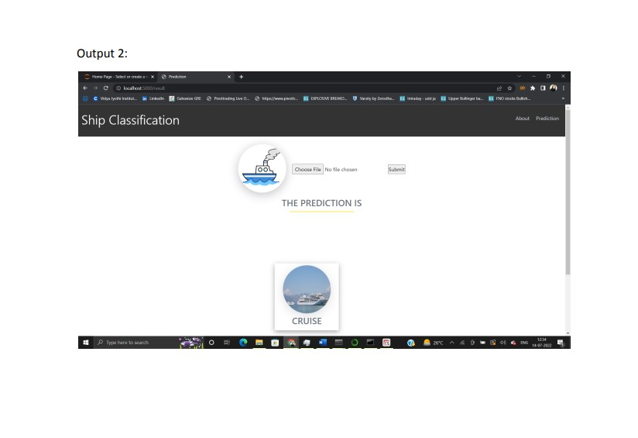

**8.ADVANTAGES AND DISADVANTAGES**

Ship classification is an important process in the maritime industry for assessing and categorizing ships based on various criteria. Here are some advantages and disadvantages of ship classification**:**

**8.1 Advantages:**

**1. Safety Assurance:** Ship classification societies ensure that vessels are designed, constructed, and maintained to meet stringent safety standards. This helps reduce the risk of accidents and ensures the safety of crew, passengers, and the environment.

**2. Risk Management:** Classification provides a systematic approach to assessing and managing risks associated with ships. It helps in identifying potential issues and implementing measures to mitigate them, which can lead to lower insurance premiums.

**3. Regulatory Compliance:** Classification societies help ships adhere to international and national regulations, including safety, pollution prevention, and security requirements. This ensures that ships can navigate global waters without facing regulatory hurdles.

**4. Quality Assurance**: Classification societies assess and verify the quality of materials, construction, and equipment used in shipbuilding, helping to maintain high construction standards and the longevity of vessels.

**5. Resale Value:** Ships with a classification certificate are often easier to sell and command a higher resale value, as they provide assurance of their condition and compliance with industry standards.

**6. Operational Efficiency:** Classification societies assist shipowners in optimizing vessel performance and operational efficiency, leading to cost savings and better profitability.

**7. Environmental Impact:** Classification societies promote environmentally friendly practices and compliance with international regulations aimed at reducing the environmental impact of shipping.

**8.2 Disadvantages:**

**1. Costs:** The process of ship classification can be expensive, involving initial assessment, regular inspections, and ongoing maintenance to meet classification standards. Smaller operators may find it financially burdensome.

**2. Bureaucracy:** Classification societies may be seen as adding bureaucratic layers to the ship operation process, leading to delays and administrative overhead.

**3. Subjectivity:** Some aspects of classification, such as interpreting safety and quality criteria, can be subjective, leading to potential disputes between shipowners and classification societies.

**4. Limited Transparency:** The classification process can involve confidential information and documents that are not publicly disclosed, making it difficult for external parties to assess the condition of a vessel independently.

**5. Regulatory Changes:** Classification standards can change over time due to evolving industry and environmental regulations. Shipowners may face additional costs and modifications to maintain compliance with new standards.

**6. Limited Liability:** Ship classification societies do not assume liability for accidents or incidents. Their primary role is to assess and certify ships based on the information available at the time of inspection.

In summary, ship classification plays a crucial role in ensuring the safety and compliance of vessels in the maritime industry. While it offers several advantages in terms of safety, risk management, and operational efficiency, it also comes with associated costs, potential subjectivity, and the need to adapt to evolving regulations. Shipowners and operators should carefully consider the benefits and drawbacks of classification when deciding whether to pursue classification for their vessel

# 9. APPLICATIONS

Ship classification is a broad field that involves identifying and categorizing different types of ships based on various criteria. There are many applications for ship classification in various industries and domains. Here are some applications:

**1. Maritime Safety and Navigation:** Ship classification helps in maritime safety by ensuring that ships meet specific standards and regulations, making them safe for navigation.Ship classification societies provide guidelines and standards for ship design, construction, and maintenance to prevent accidents and mishaps at sea.

**2. Shipping Industry:** Ship classification plays a crucial role in the shipping industry by categorizing ships based on their type, size, and purpose. This information helps in fleet management and logistics planning. Classification societies provide ship owners and operators with certification and verification services to ensure their vessels comply with industry standards.

**3. Marine Insurance:** Insurance companies use ship classification information to determine the risk associated with insuring a particular vessel. The classification of a ship can effect insurance premiums.

**4. Port Authorities:** Port authorities use ship classification data to allocate berthing spaces and manage the movement of ships within ports efficiently . They also use this information to enforce environmental regulations and safety measures within their jurisdiction.

**5. Ship Design and Construction**: Ship designers and builders use classification standards to design and construct ships that meet safety, environmental, and performance criteria.Classification societies provide design review and approval services to ensure ships comply with relevant regulations.

**6. Environmental Regulation Compliance:** Ship classification can be used to assess a ship's environmental impact, including its emissions and waste management practices.Regulatory authorities may use ship classification data to enforce environmental compliance.

**7. Naval and Defense Applications:** Ship classification is essential for naval and defense purposes to identify and classify enemy and friendly vessels. It helps in targeting and strategic decision-making during military operations and surveillance.

**8. Research and Education:** Ship classification data is valuable for educational purposes, allowing students and researchers to study different ship types and their characteristics.

**9. Maritime Security:**

- Ship classification can aid in maritime security efforts by identifying and tracking vessels to prevent piracy, smuggling, and other security threats.

**10. Customs and Trade**:

Customs authorities use ship classification to assess import and export duties, tariffs, and taxes based on the type and purpose of the vessel and its cargo.

To perform ship classification, you may need access to relevant ship databases, classification society guidelines, machine learning algorithms, and image recognition technology, depending on the specific application. Keep in mind that ship classification can vary based on criteria like ship type, size, function, and even geographic region. It's important to define your specific objectives and criteria when developing ship classification applications.

# 

# 10. CONCLUSION

In conclusion, ship classification is a multifaceted field with a wide range of applications across various industries and domains. It plays a crucial role in ensuring maritime safety, efficient logistics, and regulatory compliance. Key applications of ship classification include supporting the shipping industry, maritime safety and navigation, marine insurance, port management, ship design and construction, environmental regulation compliance, naval and defense operations, research and education, maritime security, and customs and trade. The classification of ships can have a significant impact on safety, environmental impact, and economic considerations in the maritime sector.

To implement ship classification applications effectively, you may need access to relevant databases, classification society guidelines, and potentially machine learning or image recognition technologies, depending on your specific goals and criteria. Accurate ship classification is essential for making informed decisions in various sectors and ensuring the safety and efficiency of maritime operation

# 11.FUTURE SCOPE

Future Scope of the AQI Prediction and Management System:

* 1. **Global Expansion**: Extend the system's reach to more regions and countries, addressing air quality issues on a global scale.
  2. **Advanced Technology Integration**: Integrate IoT sensor networks and smart city initiatives for real-time air quality monitoring and urban planning.
  3. **Air Quality Forecasting**: Enhance the system's capabilities for short- and long- term air quality forecasting.
  4. **Healthcare Integration**: Collaborate with healthcare providers to incorporate AQI information into patient care, particularly for those with respiratory conditions, improving public health outcomes.

**13.BIBILOGRAPHY**

Create Train and Test folders with each folder having subfolders with ship images of different types. You can collect the data from the below link:

https://www.kaggle.com/code/abdullahhaxsh/ship-classifier-using-cnn/data

Certainly, I can provide you with some references and resources that may be helpful for your ship classification project. Ship classification involves the task of identifying and categorizing different types of ships based on various features or characteristics. Here are some references to get you started:

**1. Research Papers and Journals :** "A Survey of Ship Detection and Ship Classification in Optical Remote Sensing Images" by Liang Wang, et al.

"Ship Classification Using Convolutional Neural Networks" by Hassan A. Hussein, et al.w "Automatic Ship Classification Using Ship Sketches and Convolutional Neural Networks" by Yunxiao Zhou, et al.

**2.Datasets:** [M-ARINE TREND Dataset]\

(https://marine.ign.com.br/2019-dataset): This dataset contains a large collection of ship images with different classes for classification.

**3. Online Courses and Tutorials :** Online platforms like Coursera, edX, and Udemy offer courses on computer vision and deep learning, which can be beneficial for understanding the technical aspects of ship classification.

**4. GitHub Repositories** : Explore GitHub for open-source projects related to ship classification. Many developers and researchers share their code and models, which can be a valuable resource.

5. **Books:** "Deep Learning" by Ian Goodfellow and Yoshua Bengio: This book provides a comprehensive introduction to deep learning, a key component of modern image classification techniques.

**6. Blogs and Forums :** Platforms like Medium, Towards Data Science, and Stack Overflow often have articles and discussions on image classification and deep learning.

**7. Deep Learning Frameworks** : Familiarize yourself with deep learning frameworks like TensorFlow, PyTorch, and Keras, as these are commonly used for image classification tasks.

**8. Academic Conferences:** Look into proceedings from conferences such as the International Conference on Computer Vision (ICCV), Conference on Computer Vision and Pattern Recognition (CVPR), and European Conference on Computer Vision (ECCV). These conferences often feature the latest research in computer vision.

**9. Online Forums and Communities:** Participate in online forums and communities like Stack Exchange's Data Science or Reddit's r/computervision for discussions and help from experts and peers.

**10. Documentation and Tutorials for Tools:**

- If you plan to use specific tools or libraries for your project, make sure to explore their official documentation and tutorials. For instance, TensorFlow and PyTorch have extensive documentation and community support.

Remember to tailor your research to your specific project requirements, as ship classification can vary depending on factors such as the type of data, the level of detail required, and the context in which the classification will be used. Good luck with your project!

**Model building :**

# 13.APPENDIX

1. Dataset
2. Google colab and VS code Application Building
   1. HTML file (Index file, Predict file )
3. CSS file
4. Models in pickle format

## SOURCE CODE:

## 

## 

## 

## 

## 

## 

## 

**INDEX.HTML**

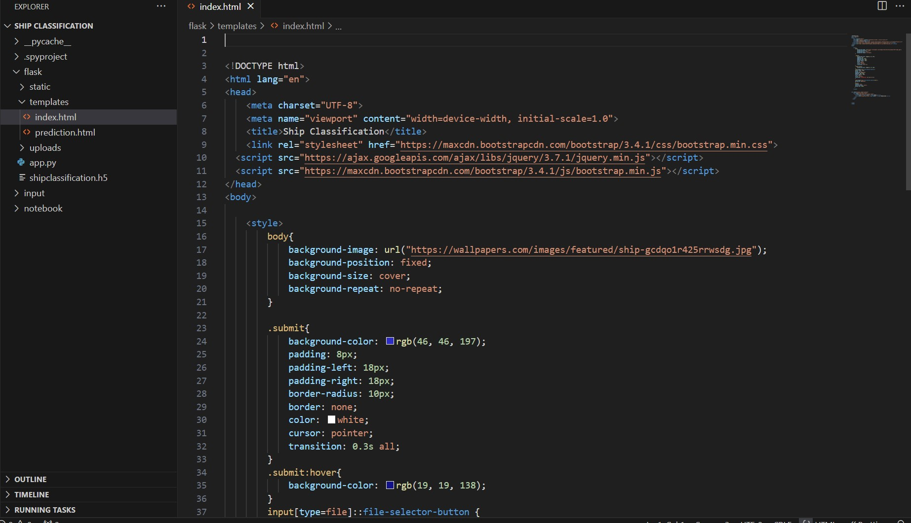

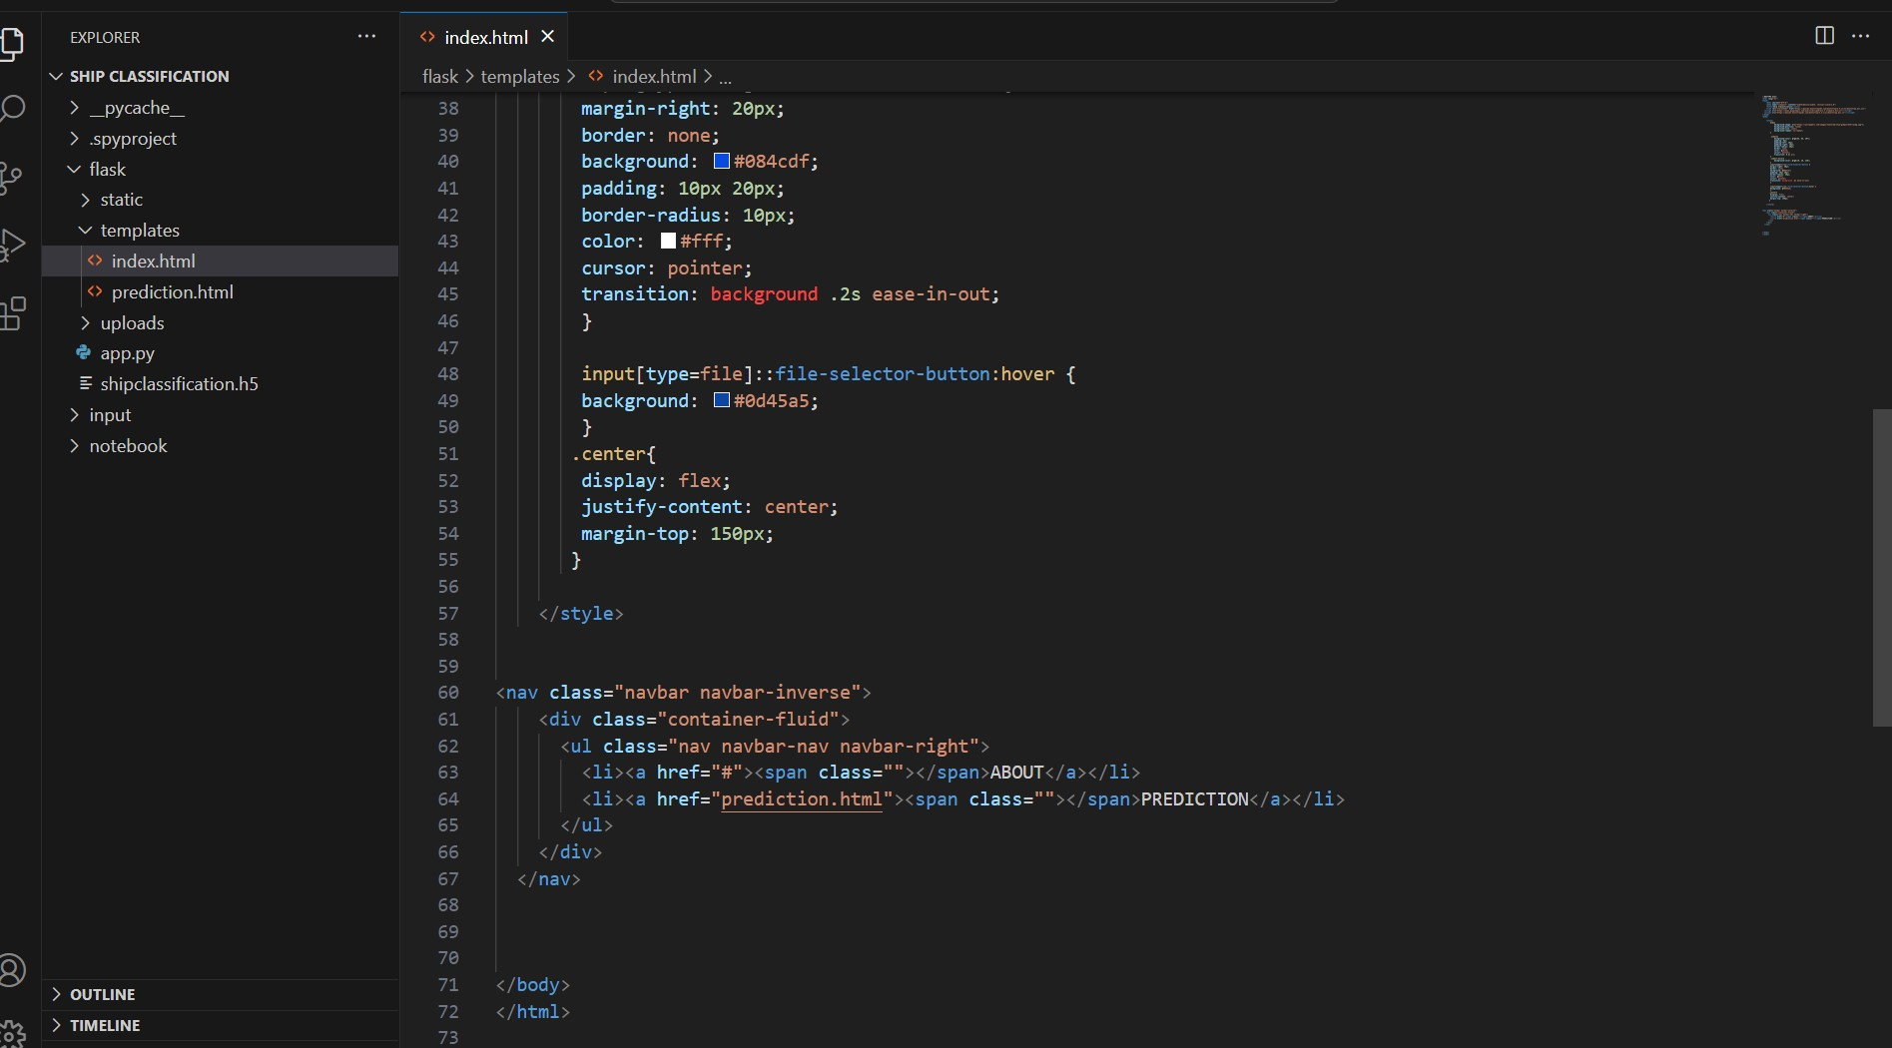

## PREDICT.HTML

## 

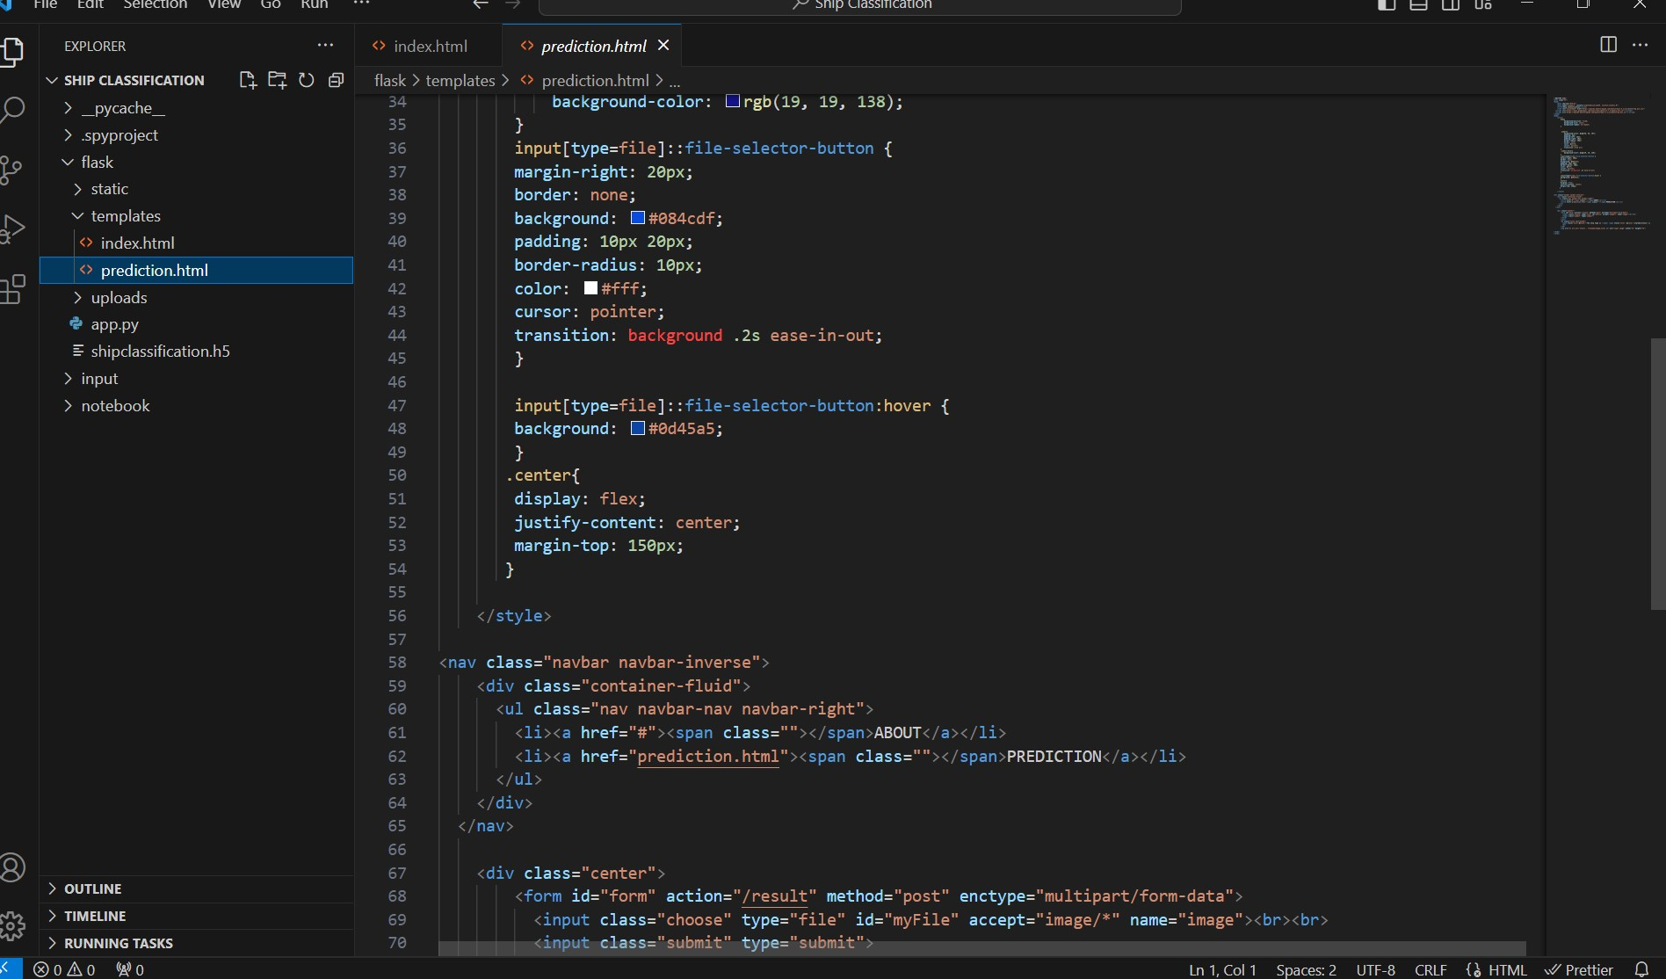

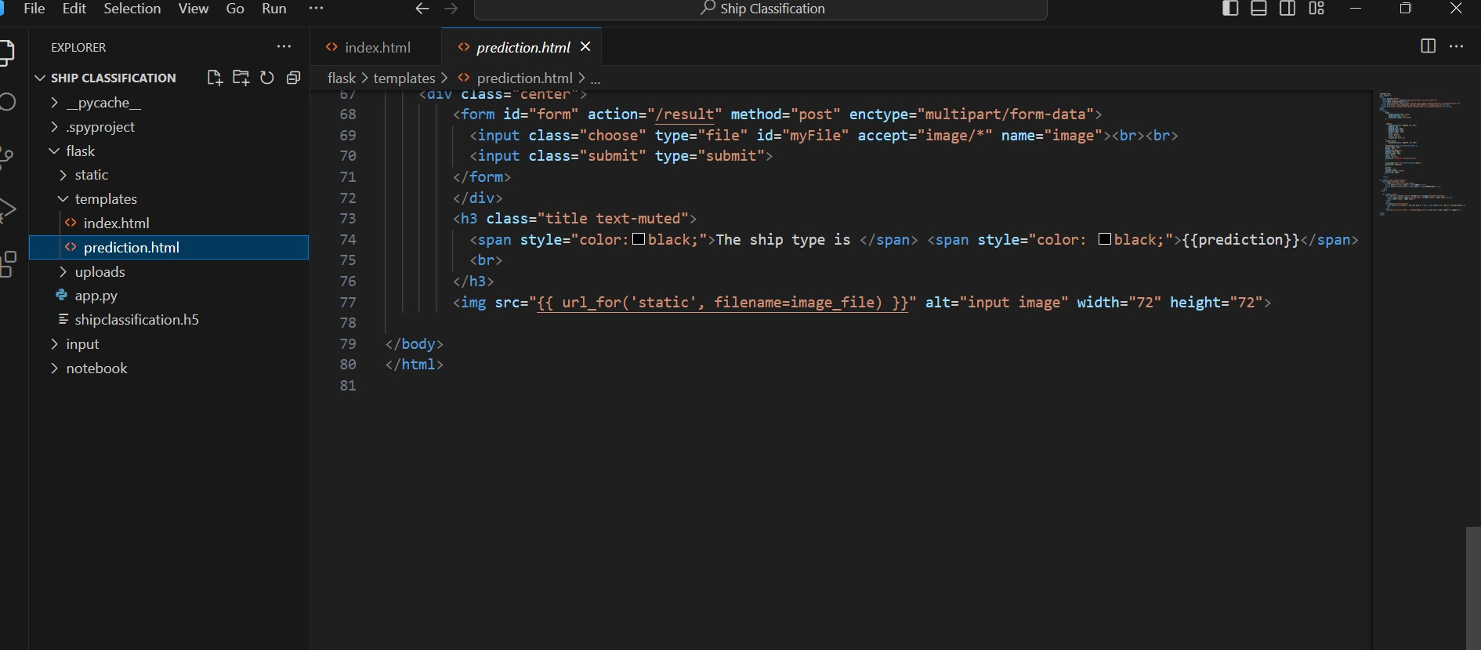

## APP.PY

## 

## 

## 

## 

## 

## 

## 

## 